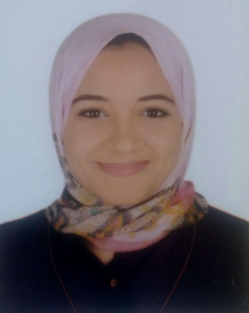
Resume'
Nada Gaber Mahmoud Hegazy
Education and Degrees | - Bachelor of Arts and Education ( Basic Education Section), English Language Branch in May 2011with the Accumulative grade//Good//  Faculty of Education, Alexandria University, Alexandria, Egypt  - Diploma in the Theory and Methodology of Teaching English to Speakers of Other Languages ( TESOL) with a grade of ( A) Excellent with Honours  Notting Hill College on 9th October 2017
Trainings and Courses | - ICDL Certified ( UNI) 2012  - Attended one day training for Content and Language Integrated Learning 2016  Notting Hill College Branch in Alexandria, Egypt  - Attended General English Course 2015  Lore Languages and Computer Centre, Alexandria, Egypt  - Attended English Course 2014  British Academy, Alexandria
Professional Experience | - Teacher of English 2019- Present  The Egyptian English Language School Alexandria, Egypt  Teaching English Language and Literature to grade 5 students  - Homeroom Teacher 2018-2019  Cedar International School( American Curriculum) Jeddah, Saudi Arabia  Teaching English, science, maths and Saudi culture to grade 1 students  - Teacher of English 2015- 2018  Brilliance Language School Alexandria, Egypt  Teaching English to grades1,4 and 5 students  - Teacher of English 2014-2015  Zahraa Almadina Private School Alexandria, Egypt  Teaching English to grades 4 and 5 students
Leadership Experience | - Freelance Translator 2017- Present  Translating Arabic texts into English and vice versa
Workshops and Conferences | - Attended an Introduction to ActivInspire ( Studio) workshop organized by Language Schools ,Alexandria , Egypt  - Attended Teacher Development Sessions organized by Egyptian English Language Schools, Alexandria, Egypt
Skills | - Language Skills  Egyptian and standard Arabic: Native Speaker  Very Good command of the English language  - Computer Skills  Microsoft Office Suite  Using Online applications for Teaching like Zoom and Microsoft Teams
Interests and Hobbies | - Reading English and Arabic novels and short stories  - Hiking  - Camping  - Travelling and sightseeing  - Playing Basketball and Doing Aerobics  - Yoga and Meditation  - Cooking  Current job specifications and all documents can be presented upon request at the interview

